Development Task 01(EDI custom feature on the Customer Card/Sales Order)
The customer wants to be able to identify whether a customer needs to be sent an EDI document (shipment/invoice)
Every document created for the customer should be flagged with the customer default
On an document by document basis (use sales orders), the user can change the default EDI requirement, but will need to enter a reason for doing so
If the default EDI requirement is changed, the document should not be able to be released unless the reason has been entered
The user wants to be able to identify, for each and specific customers, how many shipment/invoices were created which would result in an EDI file, and how many would not.

Ticket #:8070
Estimated Work Hours :16
Actual Work Hours : 5
Extension Name : Edi_customfield

Steps to reproduces:
Create a new Boolean field on the Customer Card called “Send EDI Documents”, which can be set to true or false. – ✅ DONE
Create a new Boolean field on the Sales Order called “Send EDI”. – ✅ DONE
Create a new Text field named “EDI Change Reason” to store the reason when the Boolean is overridden. – ✅ DONE
When a Sales Order is created for a Customer, the “Send EDI” field on the Sales Order Header should inherit the value from the “Send EDI Documents” field on the Customer Card. -✅ DONE
Users should have the ability to override this value on the Sales Order. When they do, they must provide a reason, which should be stored in the “EDI Change Reason” field. -✅ DONE
Create two Integer fields on the Posted Sales Shipment and Posted Sales Invoice called “Send EDI”. – ✅ DONE
Create two Integer fields on the Customer Card to track the history of EDI-enabled shipments and invoices for that specific Customer. – ✅ DONE
It should calculate the qty for the shipments/invoices with EDI feature enabled. It would be beneficial to establish a relation between these fields and the actual shipment/invoice records. - ✅ DONE

Release Notes
Add a new “Boolean” button to the Customer Card called “Send EDI Documents”, and two new fields called “EDI Shipments” and “EDI Invoices”, which are of type Integer.
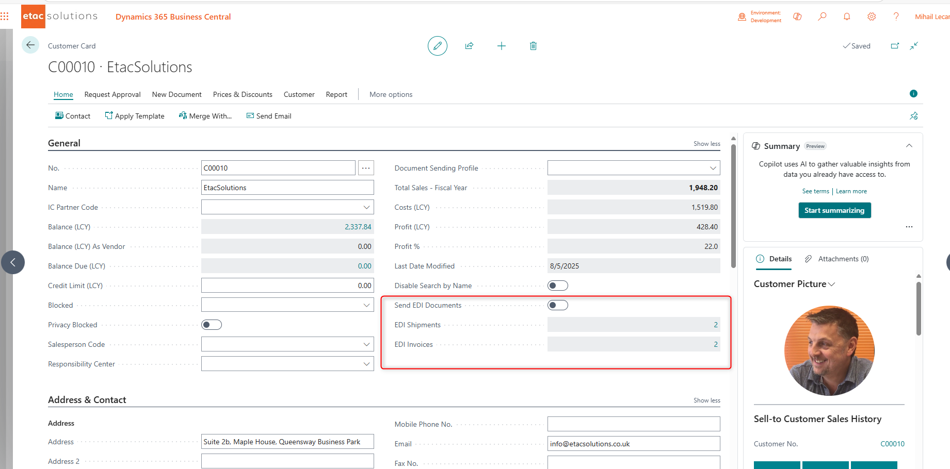
User can select whatever he needs(If we have EDI files for this Customer Boolean option have to be set to true, if we do not – set/leave to false).
Then we create Sales Order from the Customer Card or search for the Sales Order doing search.
It should bring same value as Customer set on the Customer Card.
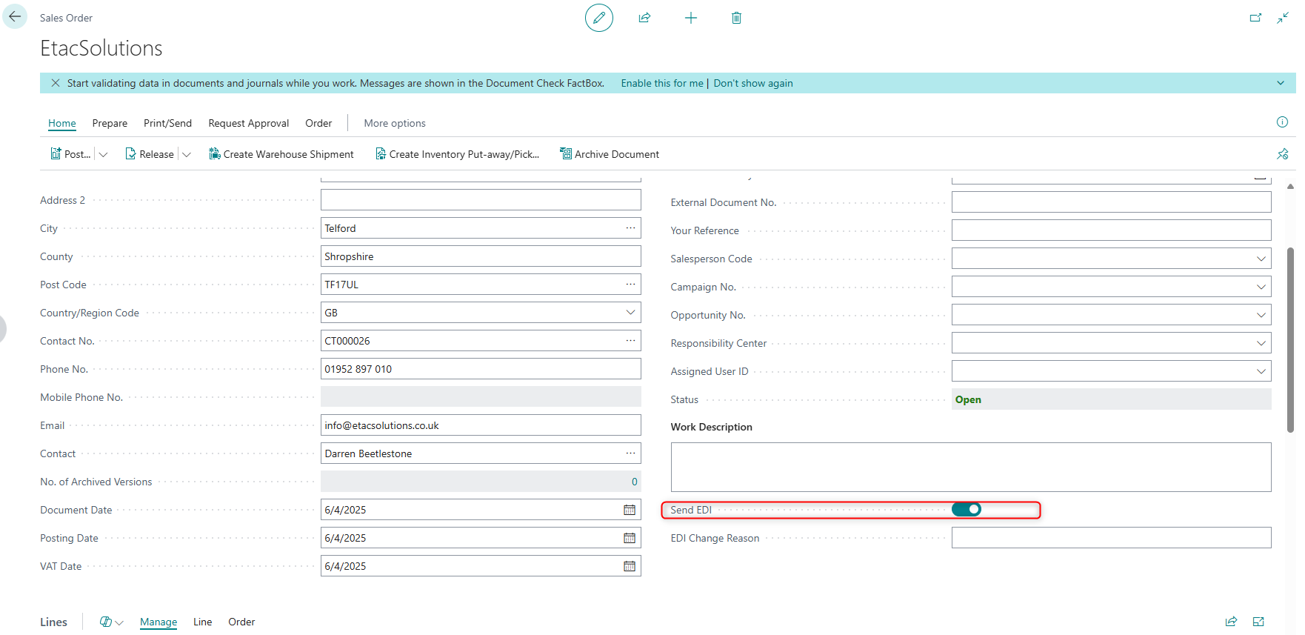

If we need to change the value of “Send EDI” button the system will give notification message -“ Please Provide the reason of change for EDI documents.”
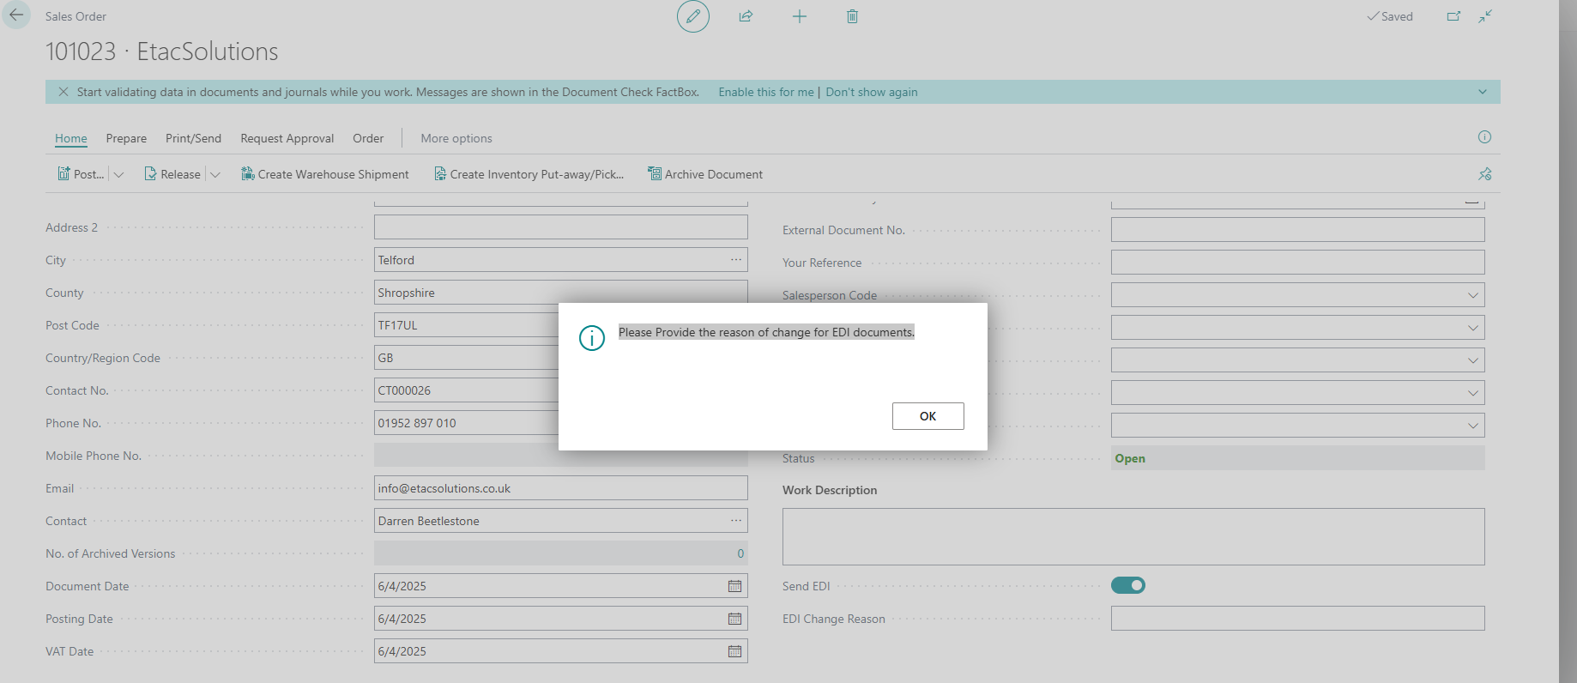
Type the Reason message and Set the field from the “true” to “false” manually or go out from the message field it should turn the Boolean field automatically
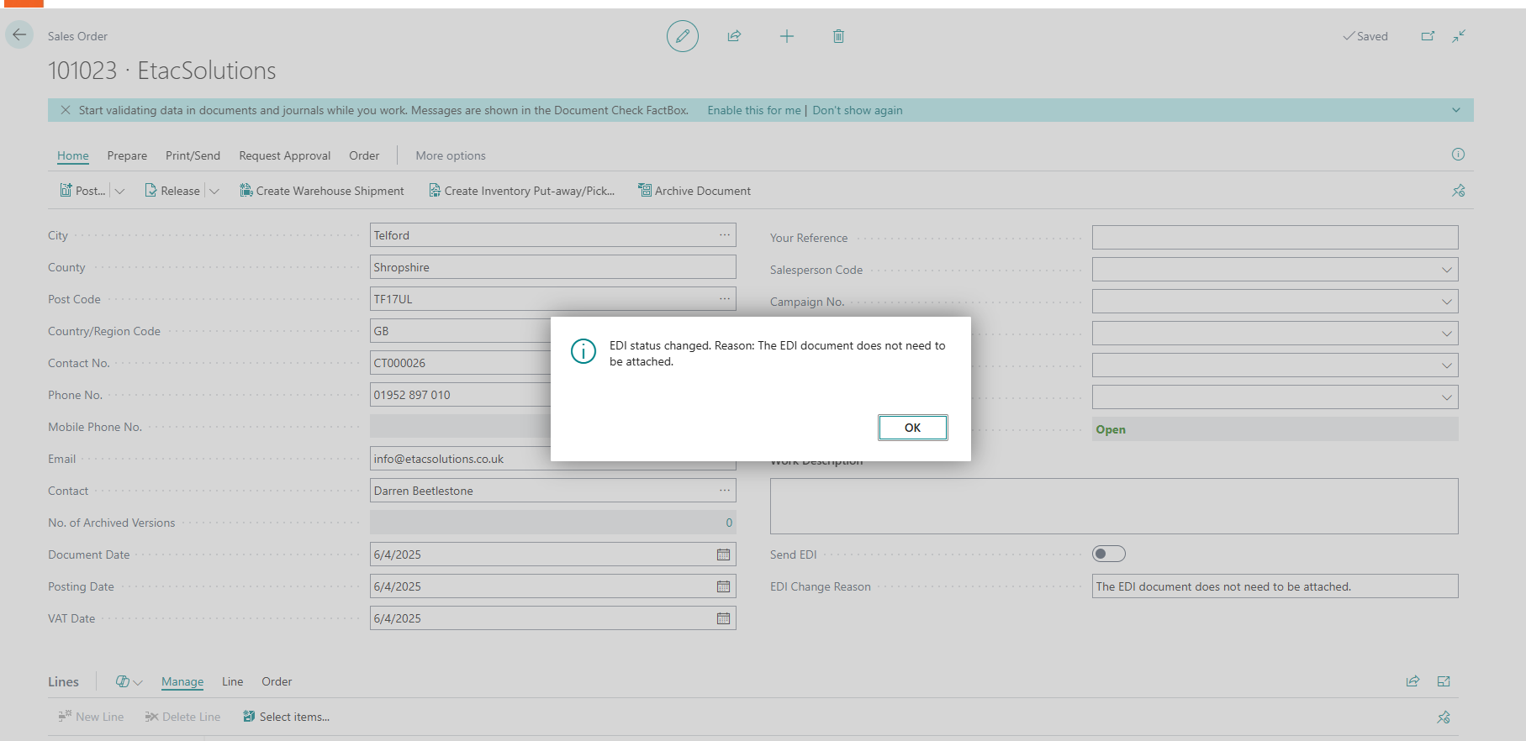

If we need to switch the field back to “true” it will defaulted to blank message
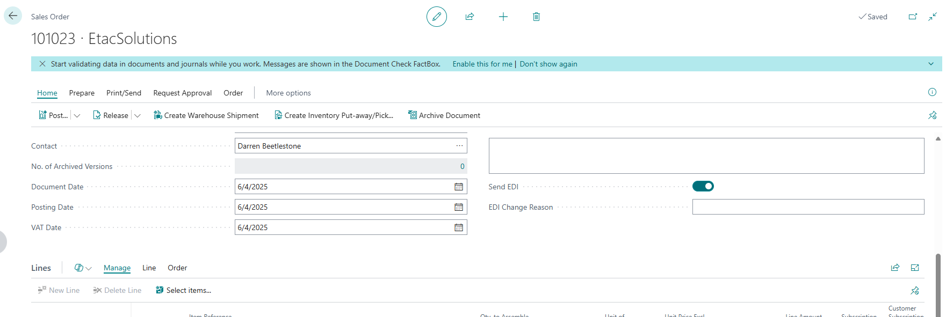
In my case I did turn to true and processed with Sales Order
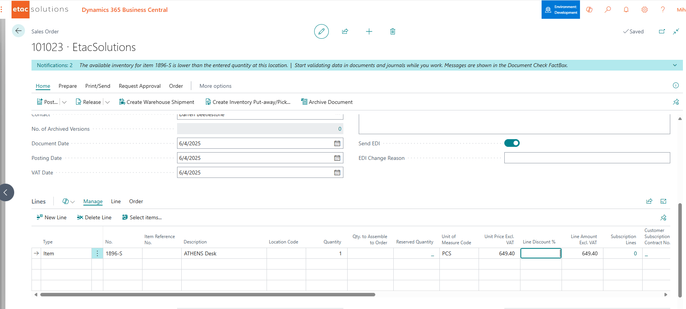

Shipped and invoiced
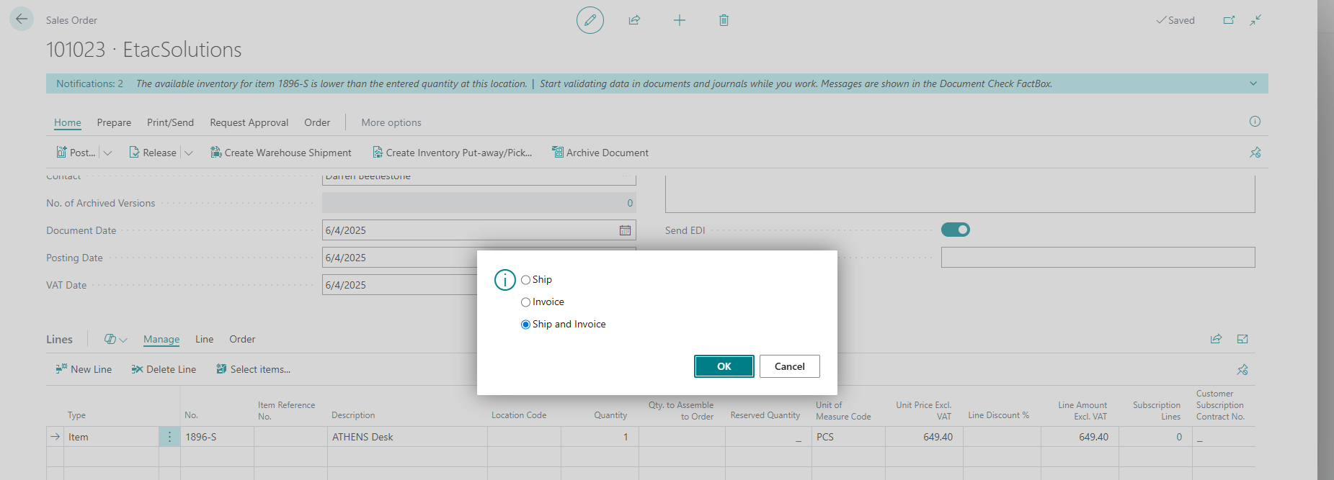

Check Posted Sales Shipment and Posted Sales Invoice
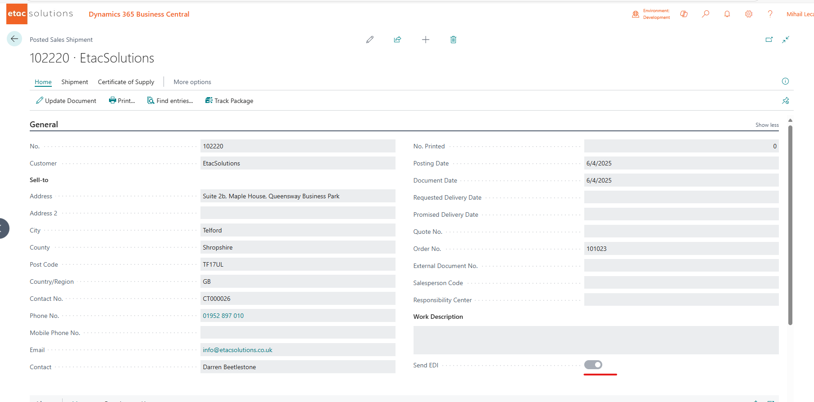
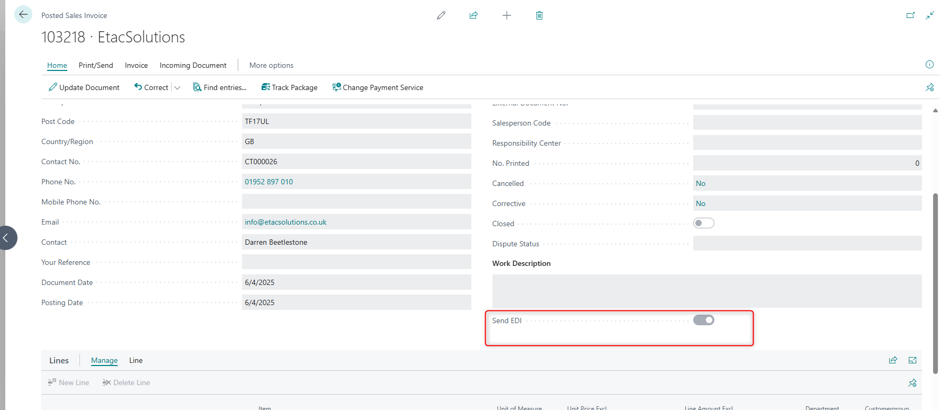

Calculation on the Item card working fine
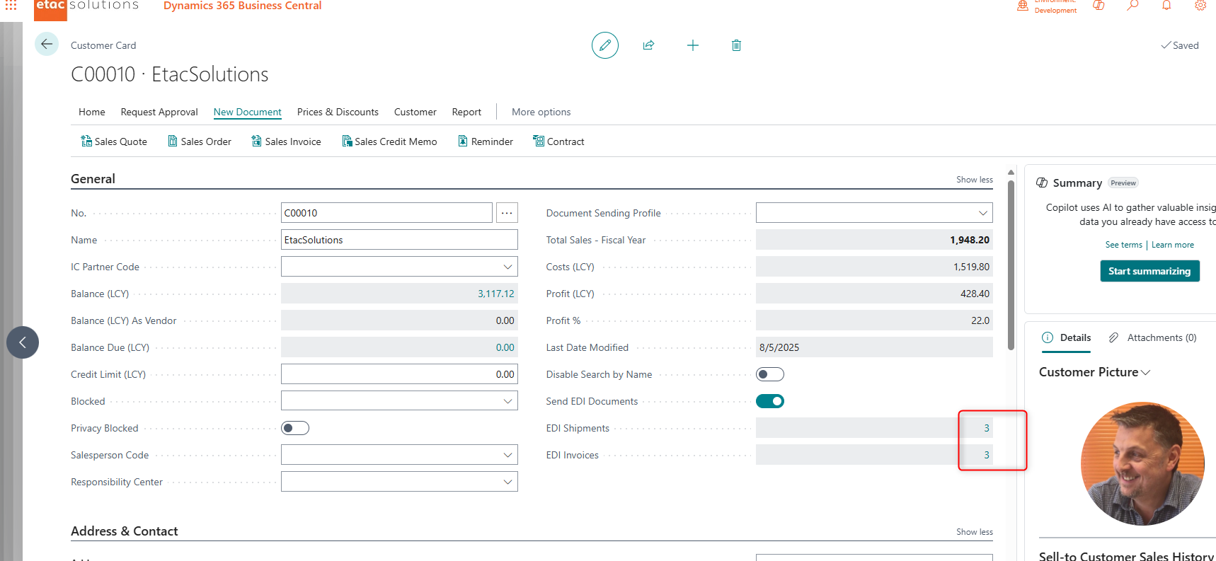

Can access to the records
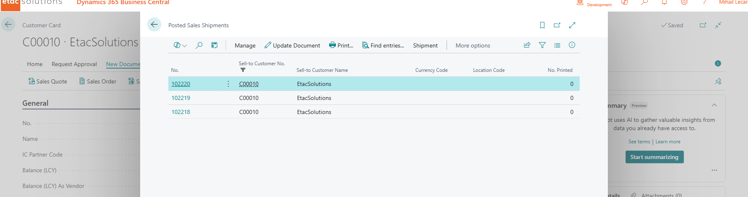
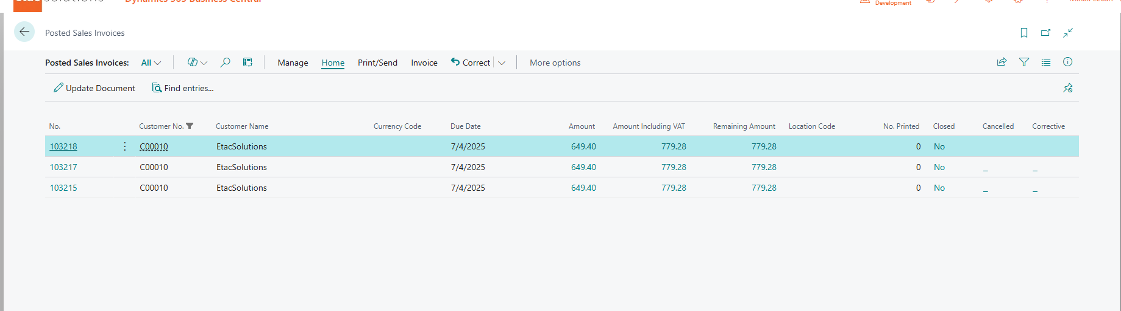ss

